**Course Outline for 202**

Tech 202

*For faculty. Prerequisite Tech 101. Pre- or corequisite Tech 201*

**1: Classroom Technology Inventory**

* Before you can determine what classroom technology you might want to learn more about or need help with, you need to know what technology is available. Walk around your classroom and record ALL of the technology that exists.
  + **Assignment:** List all of the technology in your classroom. Be sure to find model numbers when possible!
  + 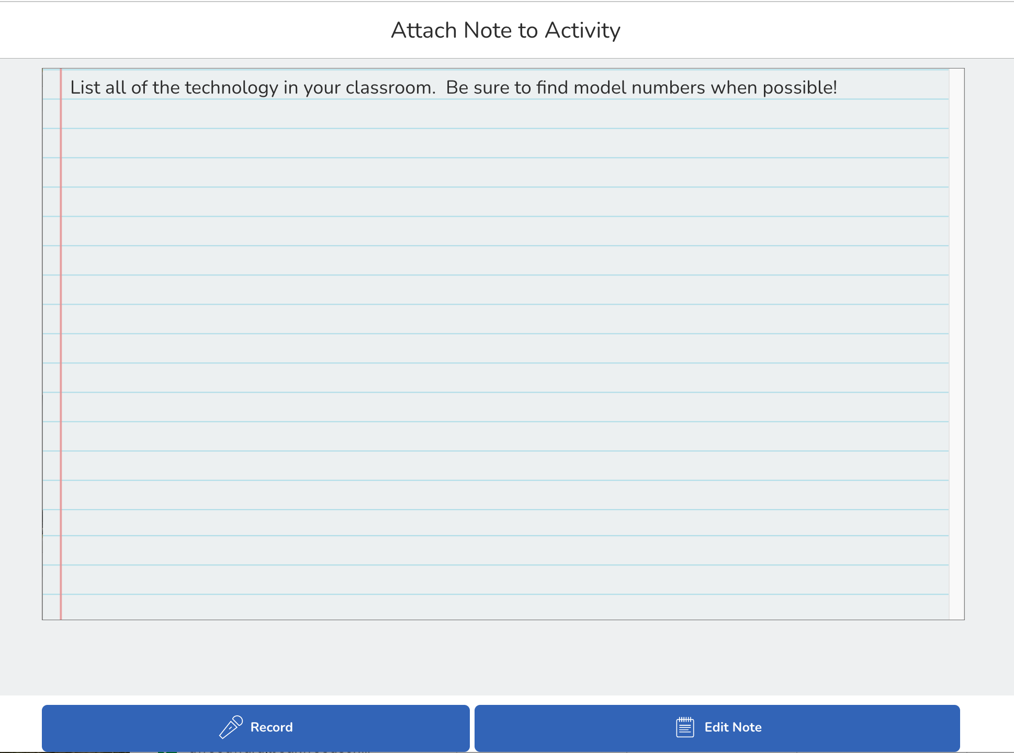

**2: Basic Troubleshooting**

* The vast majority of Tech Support tickets from the classroom are solved by restarting one or more devices. In this activity, you will determine all of the ways to restart and reset devices in your classroom and practice restarting devices.

When in doubt...TURN IT OFF AND BACK ON AGAIN!!!

* **Assignment:** For each of the items in your classroom that you identified in Lesson 1, identify all of the ways to restart/reset the device and try each method to restart/reset. Record the location/method for restarting/resetting the device below.

Your computer:

Power button -

Power cord -

Force restart -

Projector/Smartboard:

Power button -

Power cord -

Force restart -

Printer:

Power button -

Power cord -

Force restart -

Document camera:

Power button -

Power cord -

Force restart -

Speakers:

Power button -

Power cord -

Force restart -

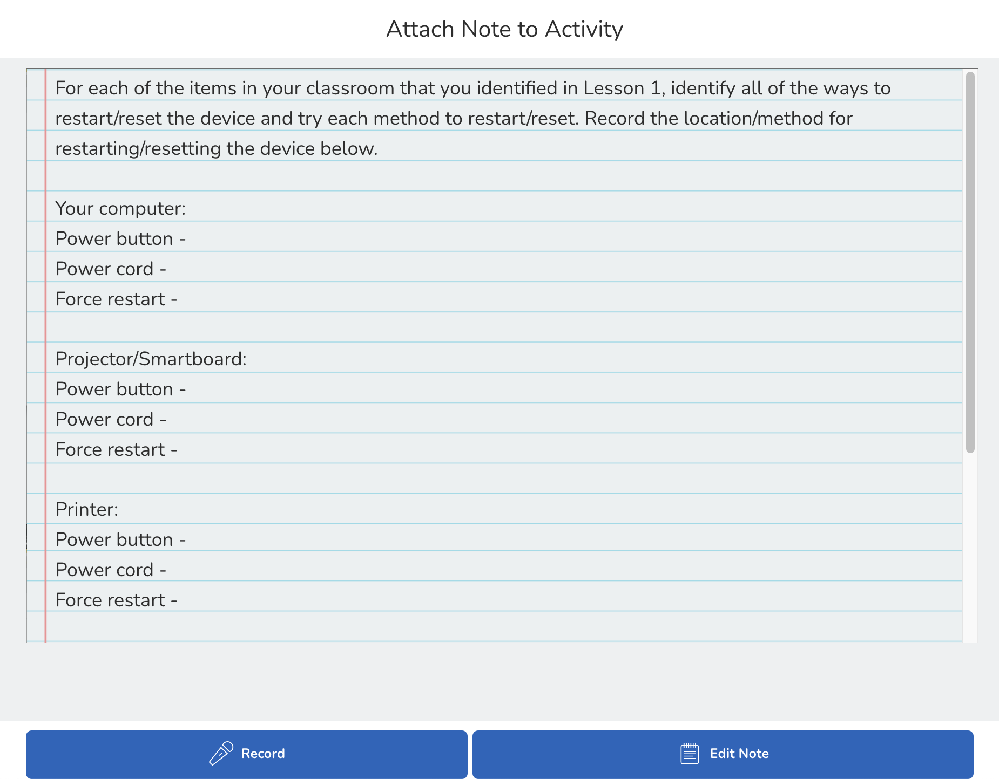

**3: Tips & Tricks for Smartboards**

* First, watch the introductory video that corresponds to the model of Smartboard in your classroom

<https://www.youtube.com/watch?v=rruSkATghG8>

Then, skim through the Teacher Guide to familiarize yourself with the array of features and options available.

<https://support.smarttech.com/docs/software/iq/en/teacher-guide/default.cshtml?cshid=teacher-guide#>

Lastly, select TWO new interactive features of the Smartboard to incorporate into one of your lessons.

* **Assignment:** Record a brief video that explains which two features you used, how you used them, and reflect on what ways they either did or did not improve the student learning experience.

**4: Using Document Cameras to Improve Student Learning**

* Watch the following video and/or read the following article for ideas on how you can use a document camera to improve the student learning experience in your classroom.

<https://www.youtube.com/watch?v=6Jdrx-cv35k>

<https://ctl.wustl.edu/encouraging-critical-thinking-with-a-document-camera/>

Then, arrange to visit a classroom when a document camera is being used to observe how one of your colleagues uses the tool.

Lastly, plan a lesson using the document camera in a new way in your classroom.

* **Assignment:** Record a brief video that explains how you used the document camera and reflect on what ways it either did or did not improve the student learning experience.